产品名称： LB 5.8G 600mW无线微波图像传收发系统

厂家编号：LB-5.8G-TX600

- LB-5.8G-TX600音视频发射器
LB-5.8G-TX600音视频发射器是工作在5645-5945MH ISM频段内的FM音视频发射器。本产品采用了高集成芯片，具有以下特性

- 发谢器特性：

* 工作频道频率：
A :
CH1:5740 CH2: 5760 CH3: 5780 CH4: 5800
CH5 : 5820 CH6: 5840 CH7:5860 CH8:5880

B :
CH1:5725 CH2: 5745 CH3:5765 CH4:5785
CH5 : 5805 CH6: 5825 CH7:5845 CH8: 5865
C :
CH1:5733 CH2: 5752 CH3: 5771 CH4: 5790
CH5: 5809 CH6: 5828 CH7: 5847 CH8:5866

D:
CH1: 5705 CH2 :5685 CH3:5665 CH4: 5645
CH5: 5885 CH6: 5905 CH7:5925 CH8:5945

* 5.8G FM音视频同步发射
* 小体积33*22*11 mm，紧凑结构，发射功率大- 采用大规模集成电路，可靠性、灵敏度高
* 工作电压7.4V-16V
* 32个工作通道，DIP开关选择设置
* 使用数字锁相环电路，无温飘现象
* 空中通信距离:>25000米
* 视频信号阻抗: 75Ω
* 天线接头: SMA(外螺内孔)
- 应用范围：航模，无线遥控飞机，飞船，玩具，监视器等。
- 引脚定义：
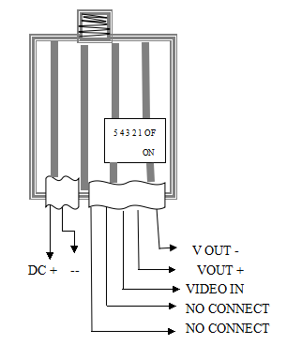

产品参数
工作频率 | 工作电压 | 工作通道 | 空中距离 | 视频号阻抗 | 天线接头（内孔）
5705-5945 | 7.4V-16V | 32 | >3000 | 75Ω | SMA

Product Name： LB 5.8G 600mWWireless Transmitting & Receiving System
Factory NO.：LB-5.8G-600

- LBTX-5.8G-600 Audio & Video Transmitter
LB-5.8G-TX600 AV Transmitter is the FM AV Transmitter which works between the frequencies of 5725 to 5945MHz ISM. This product selects high integrated chip and has the following characteristics:
- The Characteristics of the Transmitter
1. Working Frequency: 5725MHz-5945MHz
2. 5.8G FM Audio/Video Synchronization transmission.
3. A small size of 55*28*15mm, compact structure and emission powerfully- the use of large scale integrated circuits ensures the high reliability and sensitivity
4. Working Voltage: 7.4V-16V
5. 32 working channels, DIP switch selectable settings
6. Use of digital phase-locked loop circuit and there is no temperature drift phenomenon.
7. Transmitte Distance:>3000 meters.
8. Built-in Microphone and a compact size.
9. Image signal: NTSC / PAL, 1Vp-p (75 Ohm.)
10. Voice signal: dual channel 2Vp-p (2K Ohm.)
11. Antenna connector: SMA (outer screw hole)
12. Weight: 25g

二. Applications: Model Airplane/Wireless RC Plane, RC Boat and other toys.
- Pin Definition: Picture of Frenquency Control
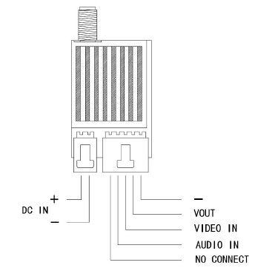
Product Parameter
Working Frequency | Working Voltage | Working Channels | Air Distance | Video Signal Impedance
5725-5865 | 7.4V-16V | 32 | >3000 | 75Ω

