产品名称： LB 5.8G 200mW无线微波图传收发系统
厂家编号：LB-5.8G-200

- LBTX-5.8G-200音视频发射器
LBTX-5.8G-200音视频发射器是工作在5645-5945MH ISM频段内的FM音视频发射器。本产品采用了高集成芯片，具有以下特性
一．发射器特性：
* 工作频率：
5.725 GHz~5.865 GHz (8 Channels @20Mhz step )
* 5.8G FM音视频同步发射
* 小体积55*28*18 mm，紧凑结构，发射功率大- 采用大规模集成电路，可靠性、灵敏度高
* 工作电压7.4V-16V
* 8个工作通道，DIP开关选择设置
* 使用数字锁相环电路，无温飘现象
* 空中通信距离:>1000米
* 自带MIC话筒， 体积小巧。
* 影像信號：NTSC / PAL， 1Vp-p (75 Ohm.)
* 語音信號：雙聲道各2Vp-p (2K Ohm.)
* 天线接头: SMA(外螺内孔)
- 应用范围：航模，无线遥控飞机，飞船，玩具等。
- 引脚定义，频率控制图
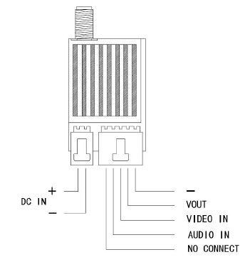
产品参数
工作频率 | 工作电压 | 工作通道 | 空中距离 | 视频号阻抗 | 天线接头（内孔）
5725-5865 | 7.4V-16V | 32 | >1000 | 75Ω | SMA

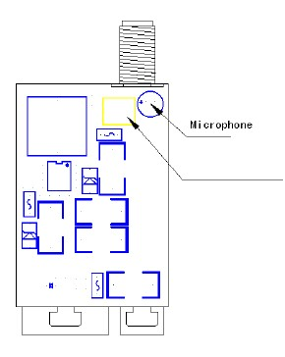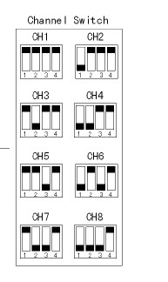

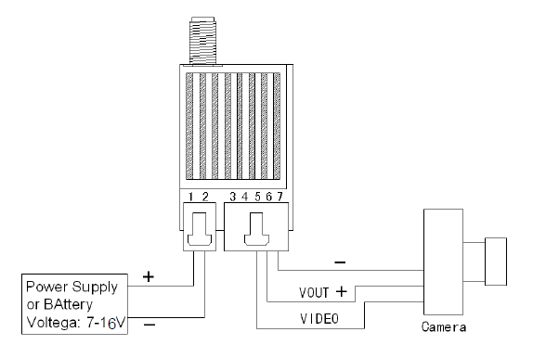

Product Name： LB 5.8G 200mWWireless Transmitting & Receiving System
Factory NO.：LB-5.8G-200

- LBTX-5.8G-200 Audio & Video Transmitter
LB-5.8G-TX200 AV Transmitter is the FM AV Transmitter which works between the frequencies of 5725 to 5945MHz ISM. This product selects high integrated chip and has the following characteristics:
- The Characteristics of the Transmitter
1. Working Frequency: 5725MHz-5945MHz
2. 5.8G FM Audio/Video Synchronization transmission.
3. A small size of 55*28*15mm, compact structure and emission powerfully- the use of large scale integrated circuits ensures the high reliability and sensitivity
4. Working Voltage: 7.4V-16V
5. 32 working channels, DIP switch selectable settings
6. Use of digital phase-locked loop circuit and there is no temperature drift phenomenon.
7. Transmitte Distance:>1000 meters.
8. Built-in Microphone and a compact size.
9. Image signal: NTSC / PAL, 1Vp-p (75 Ohm.)
10. Voice signal: dual channel 2Vp-p (2K Ohm.)
11. Antenna connector: SMA (outer screw hole)
12. Weight: 20g

二. Applications: Model Airplane/Wireless RC Plane, RC Boat and other toys.

- Pin Definition: Picture of Frenquency Control
Product Parameter
Working Frequency | Working Voltage | Working Channels | Air Distance | Video Signal Impedance
5725-5865 | 7.4V-16V | 32 | >1000 | 75Ω

